**Realtime Blood Management System**

**A PROJECT REPORT**

***Submitted by***

***Aayush Kumar Singh(21BCS7008)***

***Anoop Kumar(21BCS7055)***

***Dhuriya Ankit Subhash(21BCS6952)***

***Ishica(21BCS7050)***

***Sakshi Bajpai(21BCS6938)***

***in partial fulfillment for the award of the degree of***

**BACHELOR OF ENGINEERING**

**IN**

Computer Science and Engineering



**Chandigarh University**

MAY,2023



**BONAFIDE CERTIFICATE**

Certified that this project report **“Realtime Blood Management System”** is the Bona fide work of

**“Aayush Kumar Singh, Anoop Kumar, Dhuriya Ankit Subhash, Ishica, Sakshi Bajpai”** who carried out the project work under my/our supervision.

**SIGNATURE SIGNATURE**

Er. Puneet Kumar Divya Verma

**SUPERVISOR**

**HEAD OF THE DEPARTMENT** Assistant Professor

Computer Science Engineering Computer Science Engineering

Submitted for the project viva-voce examination held on

**INTERNAL EXAMINER EXTERNAL EXAMINER**

**TABLE OF CONTENTS**

List of Figures ............................................................................................................................. 7

List of Tables .............................................................................................................................. 8

List of Standards ......................................................................................................................... 9

**CHAPTER 1.** **INTRODUCTION ........................................................................ 09**

1.1. Identification of Client/ Need/ Relevant Contemporary issue ...................................... 09

1.2. Identification of Problem ............................................................................................... 10

1.3. Identification of Tasks .................................................................................................... 11

1.4. Timeline ............................................................................................................................. 12

1.5. Organization of the Report ................................................................................................ 13

**CHAPTER 2.** **LITERATURE REVIEW/BACKGROUND STUDY .............. __**

2.1. Timeline of the reported problem ................................................................................... 14

2.2. Existing solutions ........................................................................................................... 14

2.3. Bibliometric analysis ...................................................................................................... 14

2.4. Review Summary ........................................................................................................... 14

2.5. Problem Definition ............................................................................................................. 14

2.6. Goals/Objectives ................................................................................................................ 14

**CHAPTER 3.** **DESIGN FLOW/PROCESS ....................................................... 14**

3.1. Evaluation & Selection of Specifications/Features ........................................................ 14

3.2. Design Constraints ......................................................................................................... 14

3.3. Analysis of Features and finalization subject to constraints .......................................... 14

3.4. Design Flow ................................................................................................................... 14

3.5. Design selection ............................................................................................................. 14

3.6. Implementation plan/methodology ................................................................................ 14

**CHAPTER 4.** **RESULTS ANALYSIS AND VALIDATION ............................ 14**

4.1. Implementation of solution ............................................................................................ 14

**CHAPTER 5.** **CONCLUSION AND FUTURE WORK .................................... 15**

5.1. Conclusion ......................................................................................................................... 15

5.2. Future work ....................................................................................................................... 15

**REFERENCES ..................................................................................................... 16**

**APPENDIX ........................................................................................................... 17**

1. Plagiarism Report ................................................................................................................. 17
2. Design Checklist .................................................................................................................. 17

**USER MANUAL ................................................................................................. 18**

**List of Figures**

**Figure 1.1.1** Pie chart of blood management survey.

**Figure 1.4.1** Gantt Chart

**Figure 2.1 …………………………………………………………………………….……**

### List of Tables

**Table 1.2.1** Requirement of blood for different transfusion.

**Table 3.2 ……………………………………………………………………….………….**

**Table 4.1 ……………………………………………………………………….…….……**

### List of Standards (Mandatory For Engineering Programs)

|  |  |  |  |
| --- | --- | --- | --- |
| **Standard** | **Publishing**  **Agency** | **About the standard** | **Page no** |
| IEEE  802.11 | IEEE | IEEE 802.11 is part of the IEEE 802 set of local area network (LAN) technical standards and specifies the set of media access control (MAC) and physical layer  (PHY) protocols for implementing wireless local area network (WLAN) computer communication. | Mention page nowhere standard is used |

Note: Text in Red is presented as an example (replace with relevant information)

**ABSTRACT**

**-****---------------------------- New Page -------------------------**

**GRAPHICAL ABSTRACT**

**---------------------------- New Page -------------------------**

**ABBREVIATIONS**

**---------------------------- New Page -------------------------**

**SYMBOLS**

**---------------------------- New Page -------------------------**

**CHAPTER 1**

**INTRODUCTION**

1. **Identification of Client/Need/Relevant Contemporary issue**
   1. According to a study conducted by WHO in 2022, almost 12,000 people die regularly because of not getting the blood required in time. This includes not getting blood at time or not having the required blood type.
   2. A report released by "Johns Hopkins Medicine" in the journal "Anesthesia & Analgesia" discovers that the blood stored in cold storage for longer than 3 weeks begins to lose the capacity to carry oxygen. This is way shorter than the 6 weeks standard for most blood banks.
   3. Reports from “Indian times” (also known as times of India) and “The New Indian Express” says, that the estimated death per day because of blood unavailability is more than 12,000 in India. Most of the times a person is not aware about the donors near them, because of which time became a big factor which threaten the life.
   4. Blood Banks:
   * Gives proper details about inventory so that blood bank can request/arrange missing stock of blood
   * Will have proper details about blood as date_recieved, donor_name, donor_health and more
   1. Blood donors (or Blood donation organizations):
   * Will be able to give details directly from donors to blood banks which will be seamless and paperless
   * Making the others know about the benefits of donating blood and inspiring them to help the patient by becoming an active donor.
   1. Hospitals / Patients:
   * Would be able to request the relatively fresh blood of the suitable type.
   * Easier way to find the required blood, near to their location. Including the details of the doner for the emergency contacts if to be made.

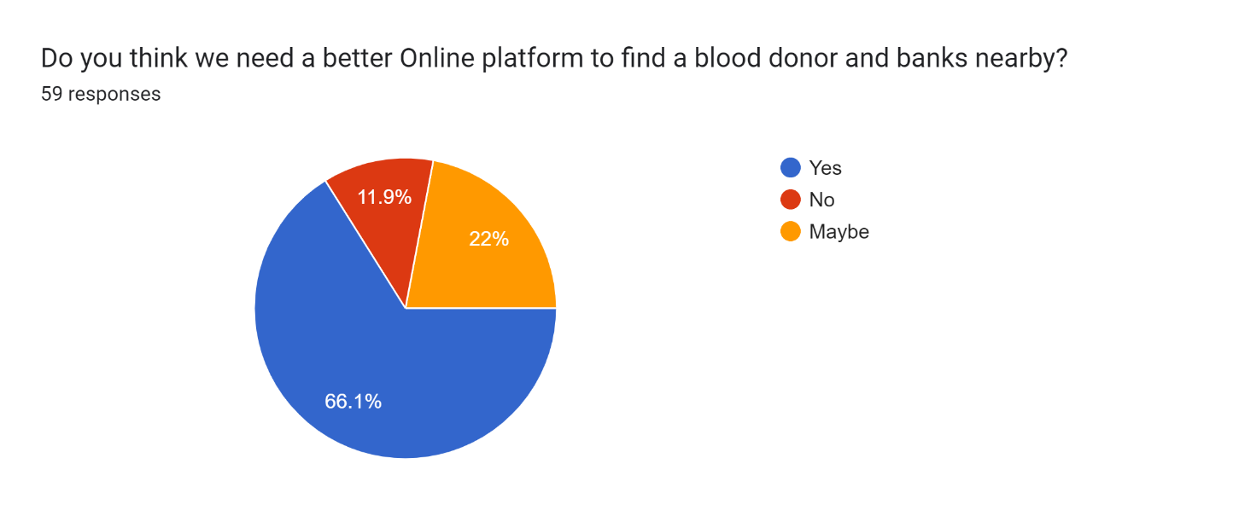

***Figure 1.1.1:*** *Pie chart of blood management survey*

As given in the *Figure 1.1* survey done by us also say the same, majority of people (66.1%) think that we need a better system related to this matter and 22% of people believe that maybe there must be a better way to provide help in this field.

1. **Identification of Problem**

Medical science may had been developed till now, but the way the facility reaches to the patients had remained same because of which some patients who can be saved at that fraction of time also gets an unnecessary death. In today’s world everything is online and has an efficient way to serve people by their service but medical is the only field which seem to be fall out of this race of development in terms of reaching to the needed ones.

And even if the facilities are provided, they are not so good enough to provide users a simple interface and ease to use that interface.

The major cause of death is because of unavailability of blood or lack of awareness related to the blood transfusion. Even though if the blood is arranged there are some issues with the blood or with the donor which can be life threatening to the patients.

While finding the compatible blood some common issues are face by the individual:

* Availability of blood nearby.
* Compatibility issues in blood.
* Lack of awareness about nearby donors.
* No online medium to check nearby availability.
* No direct interact with donor provided.

These problems are mostly faced because of no online medium availability to find the donor of blood groups needed nearby the location of a recipient.

Some real examples of Blood use in daily bases in India:

|  |  |
| --- | --- |
| Types of cases | Amount of blood required |
| Automobile Accident | *50 units of blood* |
| Heart Surgery | *6 units of blood / 6 units of platelets* |
| Organ Transplant | *40 units of blood / 30 units of platelets* |
| 20 bags of cryoprecipitate | *25 units of fresh frozen plasma* |
| Bone Marrow Transplant | *120 units of platelets/ 20 units of blood* |
| Burn Victims | *20 units of platelets* |

***Table 1.2.1:*** *Requirement of blood for different transfusion.*

**criteria for blood donation**

1. **Identification of Task**

Real-time Blood management system is a way to facilitate a person by providing them a way to make the arrangement of the needed blood type required. This is a system which provides an interface to the user through which their problem can be solved in a fraction of seconds.

In this system we had tried to make this interface which will resolve this problem by making them aware about the donors and blood banks near them by using Realtime updates. In the process of making this system there was two major terms to be discussed and these terms are told below further in this document.

The two major work in making this Real time blood management is that must have and easy to understand UI/UX and the second is to have a database connected to it, which will provide the information to the front-end or interface to show the information which is needed by that person/user.

The front page or the landing page of our system will be the information interface which will provide a brief introduction about the system and the way we provide user help, after sliding a little below a person will get two options; if a person wants to became a donor or a person is in need of blood. As per their choice the webpage will get refreshed and a webpage with the needed information will get opened.

If a person wants to became a donor, he/she have to fill a form will the essential details like:- First Name, LastName, Email ID, Aadhaar Card ID, Address, Pin code and Mobile Number.

And, if a person needs blood, then there will be an option to fill about the type of blood, he/she want with any specific blood components or whole blood and then the list of the donors near his/her location will get visible and the preferred blood banks.

Sign in will only be compulsory when the person wants to be an Active donor.

About the database from where we fetch the data will get update as per the availability of the blood groups.

The whole backend load is given to the server and the database from where we fetch the data to show the information at the interface/user side.

The webserver will be responsible for performing various tasks like: -

* The webserver is responsible for performing various tasks like:
* interacting with Front-end for blood donations and requests,
* finding suitable blood for patients
* interacting with the database for insertion of suitable blood donation entries
* rejection of blood donation which come from donor suffering from any blood disease.

The Database included in the backend is responsible for the following operations: -

* Storing data from blood donations
* Has a detail record of all the blood requests
* Stores data about the current inventory of the blood bank.

The major goal of this system is to provide a functioning system to the users, where they find the specific needed blood and the ones who want a platform to help other by donating the blood to the needed ones at their worst times, but the donor must be physically fit to be an active donor.

1. **TimeLine**

The project timeline is divided into various phase which are listed below:

* **Phase 1 (Project Definition)**

This phase involves with the research and definition of project scope. It deals in introducing us to the background knowledge required to build the project like shelf-life of blood, current shortage of blood and so on. The phase also deals with the division of task within the team and planning of deadlines.

* **Phase 2 (Content Phase)**

This phase deals with creating Skeleton or idea of how the end-product should be expected to function. This phase also deals with the actual content that is present as well as the arrangement of the content.

* **Phase 3 (Design Phase)**

This phase deals with the details like the user-experience and interface of the project. It also details with the review of the page design so that any underwhelming page design could be reworked and improved in this phase.

* **Phase 4 (Development Phase)**

This phase deals with actual development of the project. In this phase, all the coding related to the front-end and back-end of the project. At end of the phase project will be fully functional.

* **Phase 5 (Review Phase)**

In this phase, the research paper related to the project is created and the project report is created. The project is fully functional and can be given for grading.

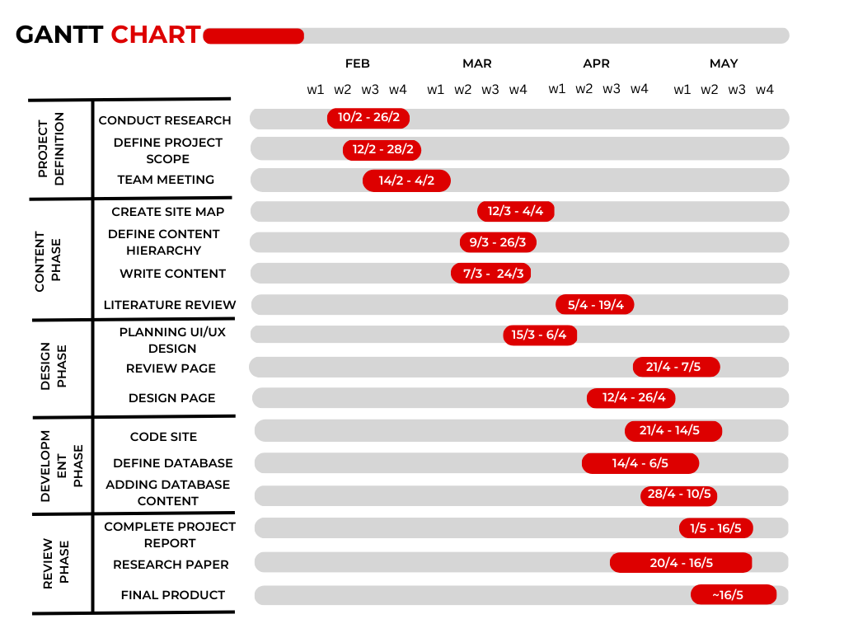

***Figure 1.4.1:*** *Gantt Chart*

1. **Organization of Report**

In this section we will be providing an overview of our project report. Our project report will be having five major chapters:

* 1. Introduction
  2. Literature Review/Background Study
  3. Design Flow/Process
  4. Result Analysis and Validation
  5. Conclusion and Future Scope

In ***Introduction*** section we are providing the basic idea of our project that what we are expecting our outcomes to be. It also includes the problem identification and client requirement from the real-world scenario which is the base of our idea behind this project.

In ***Literature Review/Background study*** we are going to describe the ideas which we got from the pre-existing project for blood management system and what are the problems and shortcomings in those projects and out of those shortcomings what we will try to implement in our project.

In ***Design Flow and Process*** we are going to choose the Design of our system from the various designs we proposed and will discuss about the facilities we are going to provide in our system. It will also contain the description of flow of our project.

In ***Result Analysis and Validation*** part we will be validating the actual outcomes of our project along with the Limitations of our project. We have also mentioned the difference between what we thought of and what we have created i.e., difference between our actual and expected outcomes.

In Last phase, ***Conclusion and Future Scope***, we will talk over the advancements with which we have concluded it in context of pre-existing projects over this topic. In this phase we will also state about the future research areas for our system.

**CHAPTER 2**

**LITERATURE REVIEW/BACKGROUND STUDY**

* + 1. **Timeline of the reported problem**

When a person willingly gives blood to be used for transfusions or fractionated to create biopharmaceutical drugs, this is known as donating blood (separation of whole blood components). Blood components or entire blood might be directly donated (apheresis). Blood banks frequently take part in both the operations that come before and after the collection process.

**1.1 History**

India's tradition of voluntarily giving blood began in 1942, during the Second World War, when blood donors were needed to assist the injured soldiers. In March 1942, the All-India Institute of Hygiene and Public Health in Kolkata, West Bengal, opened the country's first blood bank, which was run by the Red Cross. After the war, there were fewer voluntary donors and blood had to be purchased from donors. The government established the National AIDS Control Organization (NACO) in 1992 to monitor the policies in preventing the spread of AIDS as a result of the HIV pandemic in the 1980s. The National AIDS Control Project was then established, which improved patient screening and hygienic transfusion practices. The practice of selling blood was outlawed on 1 January 1998 as a result of a public interest lawsuit that was brought before the Supreme Court in 1996. Due to the fact that voluntary donations were still not very high, there was a brief scarcity of blood.

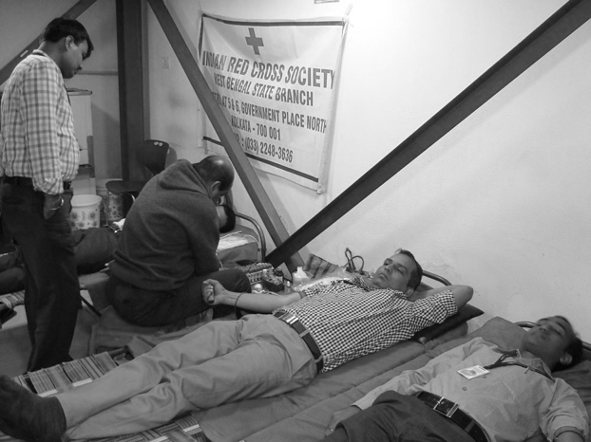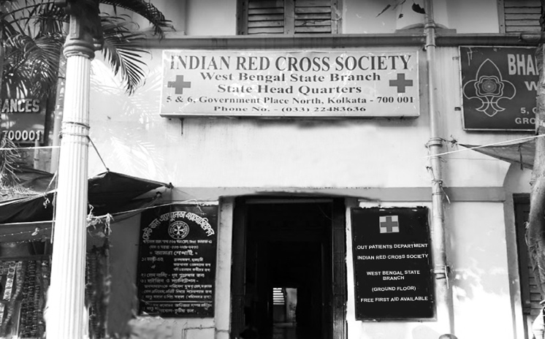

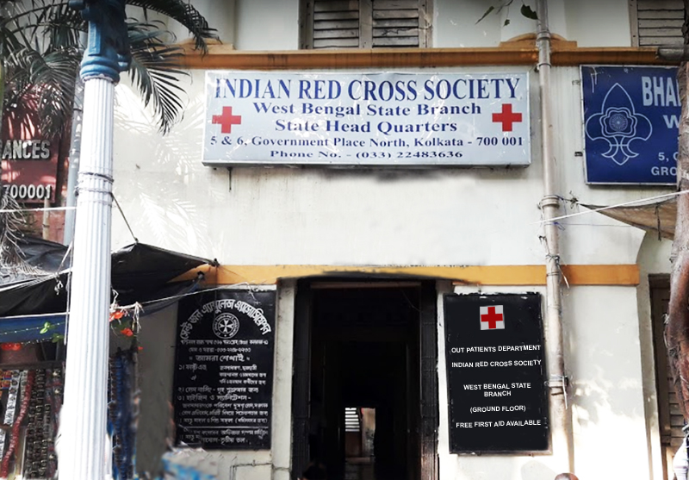

***Figure: -*** *India first blood bank*

**1.2 Criteria to Donate Blood**

The qualifications of a person to give blood are based on a number of factors. Blood banks must follow the Ministry of Health, Government of India's guidelines while screening donors.

Vital signs and general health: -

* The donor must be in good physical and mental health and free from communicable diseases.
* Age and weight requirements: Must be between the ages of 16 and 65 and weigh at least 50 kilograms.
* Pulse rate: Consistently between 50 and 100.
* Minimum hemoglobin concentration of 12.5 g/dL.
* Blood pressure: Systolic range: 100-180 mm Hg; Diastolic range: 50-100 mm Hg.
* Oral temperature shouldn't be more than 37.5 °C, and body temperature should be normal.
* The interval between consecutive blood donations needs to be greater than three months.

|  |  |  |  |  |  |  |  |  |  |  |  |  |
| --- | --- | --- | --- | --- | --- | --- | --- | --- | --- | --- | --- | --- |
| **Basic**  **Qualifications** | **Age: -** 16 or older for whole blood donations (parental permission is required for all 16-year-old donors and 17-year-old donors.)  **Weight: -** At least 110 pounds (50 kg)  There are some weight and height restrictions for donors younger than 23. See chart below.  **Waiting period between donations:**   * Whole blood or red cell/plasma donations: 56 days (up to 6x/12 months) * Plasma donations: 28 days * Double red cell donations: 112 days (up to 3x/12 months) * Platelet donations: 7 days (up to 24×/12 months)   If you have any questions about the number of donations you can make in a 12-month period, please talk with our staff. | | | | | | | | | | | |
| Height/Weight Restrictions for Donors Age 18-22  Eligibility is Based on Estimated Total Blood Volume | | | | | | | | | | | | |
| **Males: -** donors who are 18-years-old and younger must weigh 110 pounds or more, depending on their hight in the following chart. | | | | | | | | | | | | |
| **Males who are: -** | | 4’10’’ | | | 4’11’’ | | | | 5’12’’ or taller | | | |
| **Must weigh:** | | 118 | | | 114 | | | | 110 | | | |
| **Females: -** donors who are 18-years-old and younger must weigh 110 pounds or more, depending on their hight in following chart. | | | | | | | | | | | | |
| **females who are: -** | | 4’10’’ | 4’11’’ | 4’12’’ | | 5’1’’ | 5’2’’ | 5’3’’ | | 5’4’’ | 5’5’’ |
| **Must weigh:** | | 146 | 142 | 138 | | 133 | 129 | 124 | | 120 | 115 |

***Table: -*** *Criteria for blood donation*

Those who fall under the following categories are not permitted to donate blood:

* have tested positive for HIV.
* enduring illnesses including heart attacks, high blood pressure, cancer, epilepsy, kidney problems, and diabetes.
* both people with severe asthma and those with active asthma symptoms.
* Formerly suffered from allergies, fits, or TB.
* consumed alcohol within the previous day.
* had a vaccination within the previous month.
* had a general surgery or major dental procedure within the previous month.
* have had a tattoo or body piercing within the last six months.
* got Hepatitis B vaccination or rabies treatment within the last six months.
* women who recently experienced a miscarriage.

**1.3 Clinical Demand**

Blood units grew from 4.4 million in 2006–2007 to 9.3 million in 2012–2013 as the percentage of voluntary blood donors rose from 54.4% in 2006–2007 to 83.1% in 2011–2012. **[7]** The Ministry of Health and Family Welfare announced that in 2016, 10.9 million units were donated compared to the required 12 million units. **[8]** The Ministry of Health and Family Welfare produced a thorough study on India's blood supply in 2018 with assistance from its various institutes. **[9]** Because to the COVID-19 pandemic, the number of donated units in 2020 was less than anticipated at 12.7 million.**[10]** The estimated number of eligible donors in India in 2022, according to a study, is 402 million. A shortfall of one million units per year was projected since the supply was only 33.8 contributions, compared to a demand of 36.3 donations for every thousand donations. At 6.0 million units, medicine had the highest blood demand, followed by surgery with 4.1 million, obstetrics and gynecology with 3.3 million, and pediatrics with 1.2 million.

* + 1. **Existing solutions**

Blood management is a complex process that involves various activities, including donor recruitment, screening, testing, storage, and distribution. Here are some of the existing solutions for blood donor and recipient management in detail:

* 1. **Blood Bank Management System**: This is a web-based Blood Bank Management System (BBMS) by **Sumazly Sulaiman,** **Abdul Aziz K. Abdul Hamid** and **Nurul Ain Najihah Yusri** in 26 July 2015, that allows hospitals to make sure that the management of the blood stock became effective, systematic, and meeting user requirements.
* <https://www.sciencedirect.com/science/article/pii/S1877042815036940#abs0005>
  1. **Online Blood Donation Management System**: This web application based Online Blood Donation Management by **Mahmood Shah, Murad Ali Shah** and **Saeed Ullah Jan** in 11th February 2023, that uses a distributed client server computing throughout the application.
* <https://papers.ssrn.com/sol3/papers.cfm?abstract_id=4354598>
  1. **Electronic Health Records:** This review article by **A. Hoerbst** and **E. Ammenwerth** in 10th May 2010, discusses the changes in Electronic Health system in reference to content, structure and technology of Electronic Health records between the year 1990 to present (2010).
* <https://www.thieme-connect.com/products/ejournals/abstract/10.3414/ME10-01-0038>
  1. **Blood bank inventory management in India:** This research paper by **N. Ravichandran** and **Harshal Lowalekar** in 20th June 2013, discusses the recent contributions in the area of blood bank management and challenges involved with Indian blood banks.
* https://link.springer.com/article/10.1007/s12597-013-0148-z
  + 1. **Bibliometric analysis**

Bibliometric analysis is the quantitative analysis of different academic paper for the purpose of providing a better insight into how the research is produced, organized and interrelated to other academic paper. Bibliometric Analysis can be used to track authors and publications who wrote the academic paper.

A Bibliometric Analysis can have the following parts:

* literature statistical Analysis
* Mathematical Model Analysis
* System Analysis
* Matrix Analysis
* Network Analysis
  1. **Key Feature of Blood bank management system: -**

Blood management systems are designed to facilitate the process of collecting, processing, and distributing blood and blood products in a safe and efficient manner.

A Blood Management System typically includes the following key features:

* **Donor registration:** The system allows individuals to register themselves as blood donors by providing their personal and medical information.
* **Blood request management:** The system allows hospitals and other healthcare organizations to request blood from the registered donors based on the blood type required.
* **Donor search:** The system allows patients and healthcare organizations to search for donors based on the blood type required and the location of the donor.
* **Blood inventory management:** The system keeps track of the blood inventory available with the blood bank and ensures that the inventory is properly managed and updated.
* **Appointment scheduling:** The system allows donors to schedule appointments for donating blood and also provides reminders for the same.
* **Donor communication:** The system facilitates communication between the donor and the patient or the healthcare organization regarding the donation process and other relevant information.
* **Reporting and analytics:** The system provides reports and analytics on the blood donation and request activities, including the number of donors, blood units donated and requested, and other key metrics.
* **SMS/Email Notifications:** This feature sends notifications to donors and hospitals about blood donation schedules, appointments, and other updates.
* **Donor Management:** This feature helps in managing the information and records of donors, including their donation history and eligibility status.

Blood Donation and Receive Management System helps streamline the blood donation process, ensure that the right blood is available for those who need it, and improve the overall efficiency and effectiveness of blood donation programs.

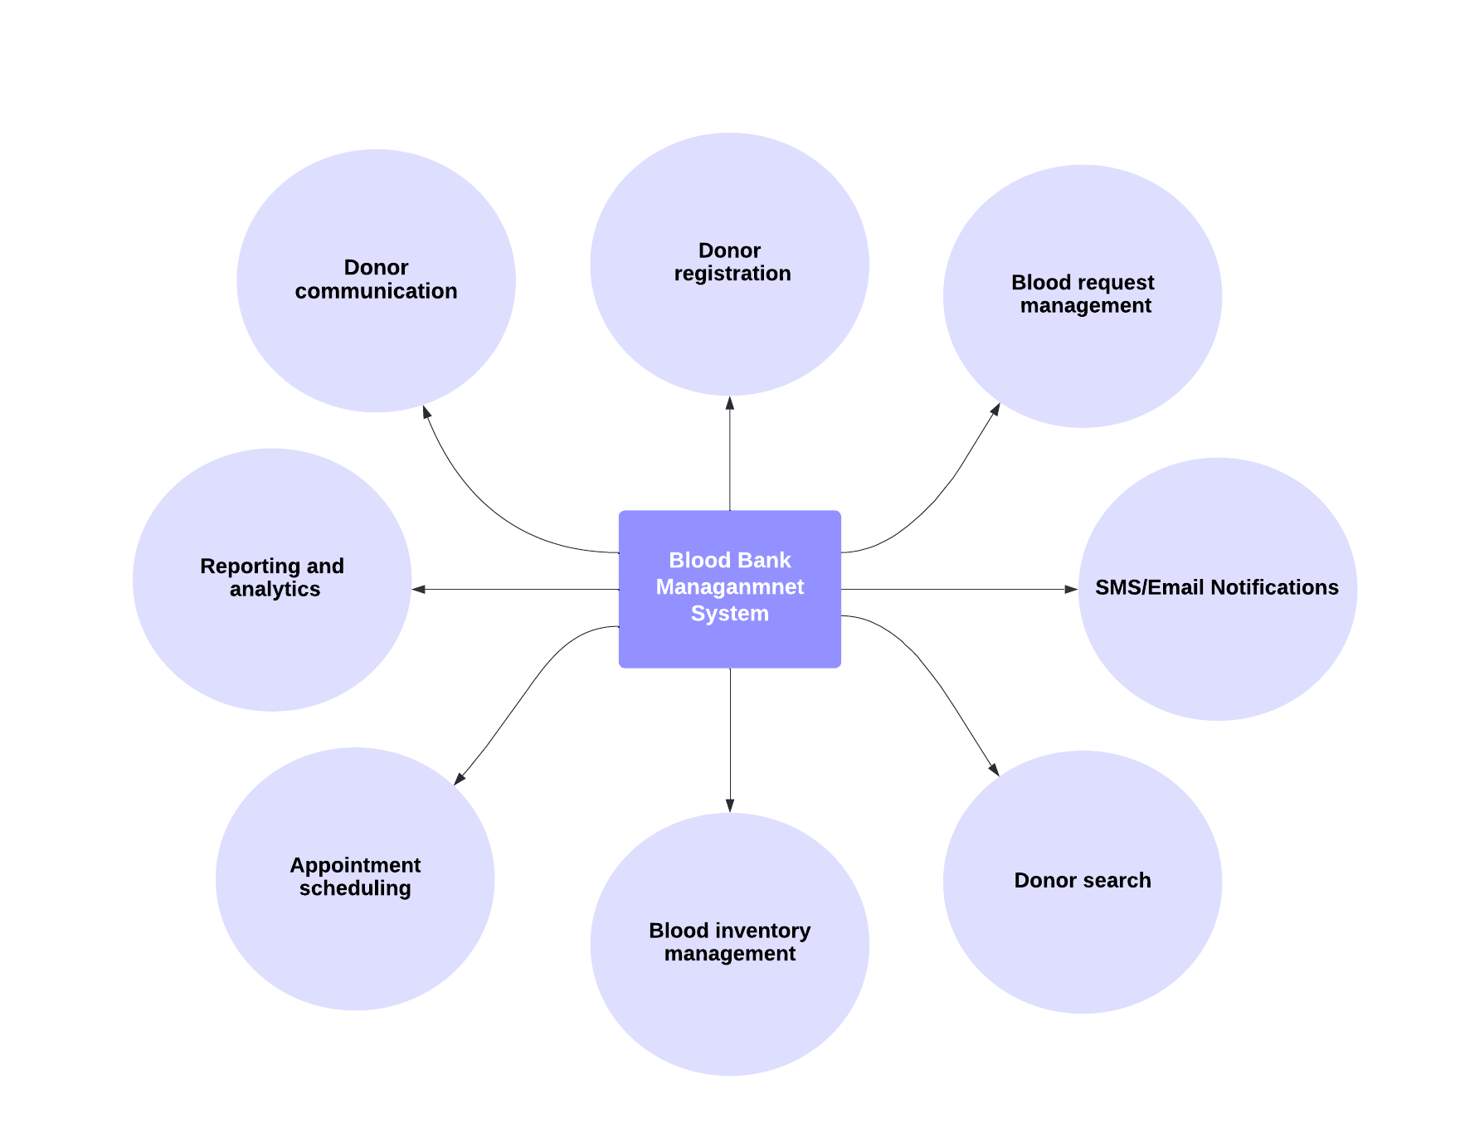

***Figure: -*** *Basic Structure of Blood Managements system*

* 1. **Effectiveness of blood management system: -**

One of the primary benefits of a blood management system is that it helps to ensure that blood is available when it is needed. By managing the inventory of blood products and tracking their distribution, these systems can help to prevent shortages and ensure that patients and healthcare facilities have access to the blood products they need to save lives.

In addition, these systems help to improve the safety of blood products by ensuring that all donated blood is properly screened for infectious diseases and other potential health risks. This helps to minimize the risk of transmitting diseases through blood transfusions and other medical procedures.

The effectiveness of blood donation and receive management systems has been demonstrated by the significant improvements in blood safety and availability that have been achieved in recent years. These systems have helped to save countless lives by ensuring that patients receive the blood products they need, when they need them, and in a safe and effective manner.

* 1. **Drawbacks of Blood bank Management System: -**

There are several potential drawbacks associated with blood donation and receive management systems. Some of them include:

* **Shortage of blood:** The biggest challenge faced by blood management systems is the shortage of blood supply. There is always a risk of running out of blood due to inadequate donations or sudden increase in demand.
* **Matching Issue:** the main drawbacks of the blood management system is the potential for errors in the matching process. There is always a risk that the blood type or other characteristics of the donated blood may not match the requirements of the recipient, which can lead to serious complications or even death.
* **Blood-borne diseases:** There is always a risk of transmitting blood-borne diseases such as HIV, hepatitis B and C, and syphilis through blood transfusions. To reduce this risk, blood donation and receive management systems must ensure that all donated blood is properly screened and tested.
* **Administrative inefficiencies:** Blood donation and receive management systems require a significant amount of administrative work to ensure that blood is collected, tested, and distributed in a timely and efficient manner. This can result in delays and inefficiencies if the system is not well-managed.
* **Donor eligibility:** Blood donation and receive management systems have strict eligibility criteria for donors, which can limit the number of eligible donors. This can further contribute to the shortage of blood supply.
* **Donor recruitment:** Blood donation and receiving management systems rely on a steady supply of donors. If donor recruitment is not done effectively, it can lead to shortages and other issues.

Furthermore, there may be logistical challenges in transporting and storing donated blood, particularly in rural or remote areas. Finally, there can be ethical concerns around the commercialization of blood donation and the potential for exploitation of donors.

* + 1. **Review Summary**

After reviewing the other proposed ideas and the literature review of the proposed projects, there are some conclusions we get form each of the articles and literature reviews. Below are some of the best conclusions which are relevant to our system.

* The BBMS is a management system developed by Sumazly Sulaiman, Abdul Aziz K. Abdul Hamid and Nurul Ain Najihah Yusri in 26 July 2015, to manage blood banks in HSNZ, meeting user requirements to ensure effective and systematic blood stock management. The present version offers profile, blood stock, and analysis management services.
* The Online Blood Donation Management System developed by A. Hoerbst and E. Ammenwerth in 10th May 2010 with the aims to gather information from individuals who wish to donate blood or require it. The web application allows users to sign up for donation or request blood online. The platform is accessible to the general public.
* This research is done by A. Hoerbst and E. Ammenwerth in 10th May 2010 to analyse the content, structure, and technology of electronic health records (EHRs) have been frequently changed and adapted to support and enhance healthcare. However, the basic idea behind EHRs has remained the same. To achieve these goals, it is important for EHRs to adhere to strict quality requirements.
* The Research paper by N. Ravichandran and Harshal Lowalekar in 20th June 2013 provides an overview of recent contributions in blood bank inventory management and relates them to the challenges specific to Indian blood banks. The current blood-banking scenario in India is studied, and the challenges unique to Indian blood banks are identified. The role of formal methods in analysing the complex problem of blood bank inventory management is reviewed, and existing research gaps in the context of blood banks are identified.
  + 1. **Problem Definition**

Blood requirement has always been the part of medical science, in any life-saving situation blood is Plays an important role and if this requirement is not met within a limited time, it can be hazardous for the life of patients.

Blood compatibility is the factor which is important in the blood transfusion. If incompatible blood is transfused, it can lead to a potentially life-threatening transfusion reaction. So, finding the compatible blood make it more difficult for the person who needs the blood.

We had already identified the problem faced by the society in the introduction part about finding the compatible blood, some problem among them is as mentioned:

* Availability of blood nearby.
* Lack of awareness about nearby donors.
* No online medium to check nearby availability.
* No direct interact with donor provided.

There must be a medium to provide a location of the donors who are compatible and are there to donate to the recipient, as lack of such system make it very hard for a person to find a blood donor of the blood group they need and even if they find a person with same blood groups, the person is eligible for donation of blood is also a question remains.

The lack of a centralized system to provide the location and eligibility of compatible blood donors can make it difficult for patients to find suitable donors. A centralized system that connects eligible donors with patients in need could simplify and streamline the process of finding compatible blood, reducing the risk of errors and misunderstandings.

One of the major issues faced by recipients and their families is the lack of a medium to check the availability of compatible blood in nearby blood banks. In such cases, the recipient's life may be at risk as they must move from one blood bank to another in search of compatible blood. This process of searching for blood can take a considerable amount of time, which is a precious resource in emergency situations.

Let the donor is located but, they are not ready to donate blood because of lack of knowledge in this field, and fear of this process. Knowledge of blood transfusion among peoples of society can also be a gap between life and death**.**

The lack of knowledge about blood transfusion among potential donors can hinder the process of obtaining necessary blood donations. This is due to fears and misconceptions about the process, which can be dispelled through increased awareness and education. By addressing the knowledge gap, more donors can be encouraged to donate blood and ultimately save lives.gap between life and death.

* + 1. **Goals/Objectives**

Blood is a basic and a crucial element for the survival of a human. Its unavailability at the right time can be responsible for the loss of the life of a person. To make the blood available at the right time for the seeker we will be providing a Realtime blood management system.

**Goal of our Project: -**

* The system will aim to bring the acknowledgement of availability of compatible blood type or its donor who is willing to donate blood at the immediate moment nearby the location of the receiver.
* Our primary goal is to provide the information of the blood availability at the nearby locations of a receiver so that a receiver can directly found the blood or the donor for the same at the moment rather than wasting time in searching for the blood through social media or by visiting blood banks.

**Milestones of the project: -**

For creating an efficient system for the same we have distributed the tasks to achieve all the milestones in different phases. A phase will not be declared as completed until we will be able to get the perfections in the expected results of a phase.

To complete the whole project in a disciplinary manner all the phases are scheduled to be completed in a particular time limit decided as per the comforts of all the team members so that all can contribute proficiently in their tasks for the respective phases to be completed on time for the fastest release of the final product.

* The research on the existing system is completed and defined the scope by making advancements in the pre-existing systems.
* The site map of the project is created and completed the documentary for the literature of our system.
* The UI/UX of the system has been created and an interface face for the user to connect with the application is about to achieve the success acc to the design mapped for the system.
* After this the team will be majorly working on the backend part for connectivity of application with database and few members from the team will be working on the documentation of the project.

According to the timeline created, all the members are contributing their best and attaining the tasks within a decide time period.

**Post developments: -**

After creating the product we will work consistently on improving the database of the system for accurate and immediate availability of the blood whenever one requires it. For this we may be increasing our connections to join hands with some organizations to provide ease to the clients.